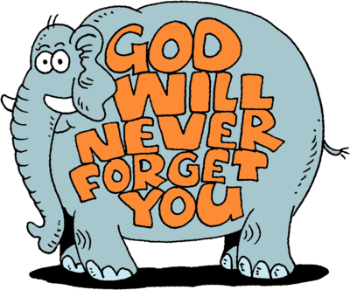
Heaven-Sent Promises in the Midst of Our Earth-bound Pain
“Everybody hurts. Sometimes.” That is the truth of this sin-filled life. We are not alone, though. While grief may be a companion in this life, Christ is still the treasure of our hearts.

Believe What?
Our final lesson will explore some of the difficult questions that can only be answered by trusting in God and what he says in his Word. Satan’s whispers can cause us to question our beliefs and doubt God’s promises. We need to lay a foundation of truth that we can turn to when seeds of doubt threaten to rob us the comfort we have in the Lord’s promises.
Focus Verse
But God shows his love for us in that while we were still sinners Christ died for us. Romans 5:8
A Strong Foundation!
We’ve been discussing the various questions that struggles can cause to rise up in our hearts and minds. At the core of those questions is doubt. Why is it so important to have a strong foundation for our belief?

HELP TO BELIEVE IN TIMES OF DOUBT
- Cling to a Confession of What is Known

- Turn to Scripture

- Be Active in Prayer

A Planned Foundation
When we are amid pain or difficulty, we tend to focus more on the hurt than the hope. Psalm 139 and the First Article of the Apostles’ Creed both confess God as our Creator.

Psalm 22:9-10.
⁹Yet you brought me out of the womb; you made me trust in you, even at my mother's breast. ¹⁰From birth I was cast on you; from my mother's womb you have been my God.

The First Article of the Apostle’s Creed
I believe in Jesus Christ his Son, our Lord, who was conceived by the Holy Spirit, born of the virgin Mary, suffered under Pontius Pilate, was crucified, died, and was buried. He descended into hell. The third day he rose again from the dead. He ascended into heaven and is seated at the right hand of God the Father almighty. From there he will come to judge the living and the dead.

Psalm 22:9-10 reinforces the foundation of faith in Christ. This psalm is David’s prophetic revelation of the work of Christ. Specifically, there is reference to Christ “being cast upon God.” What comfort can we find in that fact?

In the Apostles’ Creed, we confess Jesus Christ as Redeemer. If we were to break down the Second Article, it could be divided into four parts:

He Came:

He Died:

He Rose:
He Will Come Again:

Romans 5:8 tells us that Jesus died for us while we were still sinners. Why is that such an important truth to keep in mind?

Reflect
Revisit prayers to discover answers

Journal Prayers

Writing Prayers

